**Project Planning Phase**

**Project Planning (Product Backlog, Sprint Planning, Stories, Story points)**

|  |  |
| --- | --- |
| Date | 27 June 2025 |
| Team ID | LTVIP2025TMID59160 |
| Project Name | Citizen AI – Intelligent Citizen Engagement Platform |
| Maximum Marks | 5 Marks |

Use the below template to create product backlog and sprint schedule

|  |  |  |  |  |  |  |
| --- | --- | --- | --- | --- | --- | --- |
| **Sprint** | **Functional**  **Requirement**  **(Epic)** | **User**  **Story**  **Number** | **User Story / Task** | **Story Points** | **Priority** | **Team Members** |
| Sprint1 | Registration | USN-1 | As a user, I can register for the application by entering my email, password, and confirming my password. | 2 | High | CH.Gnana Prasunamba |
| Sprint1 |  | USN-2 | As a user, I will receive confirmation email once I have registered for the application | 1 | High | M.Nikkhath Tabassum |
| Sprint2 |  | USN-3 | As a user, I can register  for the application through Facebook | 2 | Low | K.Reshma |
| Sprint1 |  | USN-4 | As a user, I can register for the application through Gmail | 2 | Medium | G.Uday kumar |
| Sprint-  1 | Login | USN-5 | As a user, I can log into the application by entering email & password | 1 | High | K.Reshma |
|  | Dashboard |  |  |  |  |  |

**Product Backlog, Sprint Schedule, and Estimation (4 Marks)**

**Velocity:**

Imagine we have a 10-day sprint duration, and the velocity of the team is 20 (points per sprint). Let’s calculate the team’s average velocity (AV) per iteration unit (story points per day) 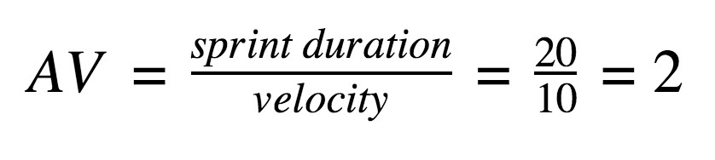

[Agile project management](https://www.atlassian.com/en/work-management/project-management) is an iterative approach to delivering a project, which focuses on continuous releases that incorporate customer feedback. The ability to adjust during each iteration promotes velocity and adaptability. This approach is different from a linear, waterfall project management approach, which follows a set path with limited deviation. With today’s customers and businesses requiring rapid responses and changes, agile provides the flexibility to adjust and iterate during the development process.

Agile project management is also a cornerstone of [DevOps practices,](https://www.atlassian.com/en/devops/what-is-devops) where development and operations teams work collaboratively